B. Sc. Semester II (Honours) Practical Examination 2020-21
Botany
Course ID: 21321 Course Code: SHBOT/201/C-3(P)
Course Title: Mycology and Phytopathology
Time: 1h 15m Full Marks: 15
The figures in the margin indicate full marks.
Candidates are required to give their answers in their own words
as far as possible

- Draw, lebel, identify and comments the specimen A 2+1+1+1=5
A

- Identify the specimen B (1+1+1)+2=5
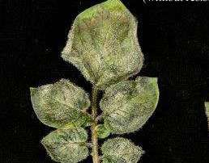
B
  - Write the name of the host, pathogen, disease
  - Write comments
- Viva-voce 5

